Event Manager in MySql engine

* This is to create a event in my sql which works as cron job in linux machines

#this cmd shows the event which are already configured in MySQL server

Show processlist;

To delete the data in Db’s which is older than 5 days this script has been written

Sample

# this creates a new event with name Db clean-up

CREATE EVENT Db_cleanup

# defining a user name to run who has permissions

Definer = user

#here we are scheduling the event at a time on everyday it will run

ON SCHEDULE EVERY 1 DAY STARTS time_stamp (when all the jobs related to this dB are completed that time we need to keep)

DO

BEGIN

# here we are using the schema name (Db_name.table_name ) to delete it from

DELETE FROM PWR_DATAFABRIC.activity

#here we are using the where condition

Where CREATE_TIME > DATE_SUB(NOW(), INTERVAL 5 DAY) ;

END

SELECT * FROM INFORMATION_SCHEMA.COLUMNS where table_name = 'activity'\G ;

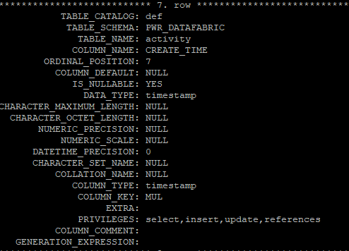

Using DATA_TYPE: timestamp variable we have to create the script and hardcore it for all db’s